Monday, November 5, 2007

N.Y./Region
October 19, 2007, 4:19 pm

Ribbet … Ribbet … a 6-Foot Frog to Play WithBy Jennifer 8. Lee
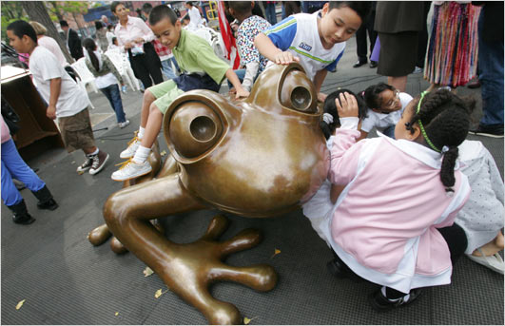Children got to know “Coqui,” Tom Otterness’s sculpture, at a playground at Public School 20 on the Lower East Side today. (Photo: Librado Romero/The New York Times)
The man behind the whimsical cartoony sculptures in the New York subways, Tom Otterness, has gone giant and amphibian on the Lower East Side of Manhattan. But instead of six-foot humans shrunk into six-inch forms, he has blown up a six-inch frog into a six-foot sculpture at the ABC playground of Public School 20, the Anna Silver School, at 166 Essex Street.
The sculpture, called “Coqui,” is named for the common Spanish name for the species of small frogs widespread in Puerto Rico, where a significant portion of the students’ families originally came from.
“Coqui,” which had its installation ceremony this morning, is the last of Mr. Otterness’s public works in New York City for the foreseeable future. Mr. Otterness has not abandoned small cuteness in favor of big cuteness. Tucked into the feet of the big coqui frog is a tiny coqui frog. “The kids go crazy over it,” he said.

